Steps for using pulse program to upgrade NTP server for redundancy

1. decompress the RZR file, read the file README

2. install winscp under windows, put the new program pulse on desktop

3. create a new site. File protocol is SFTP. Host name is the IP of the NTP server. Port Number is 22. User name is root, password is globaltime.

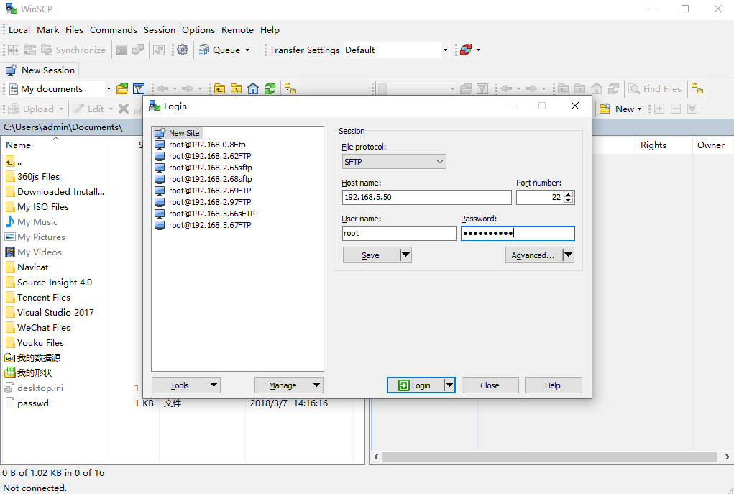

1. Put pulse program and update.sh script under /update

The original login directory is /root

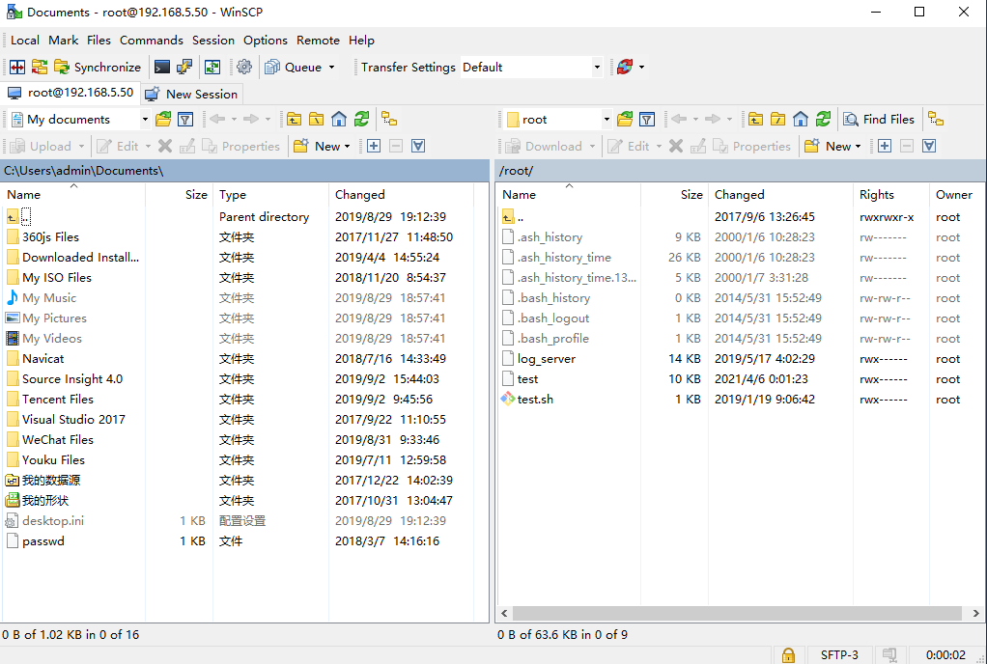

Click to up to the previous parent directory, then double click update to go to /update/

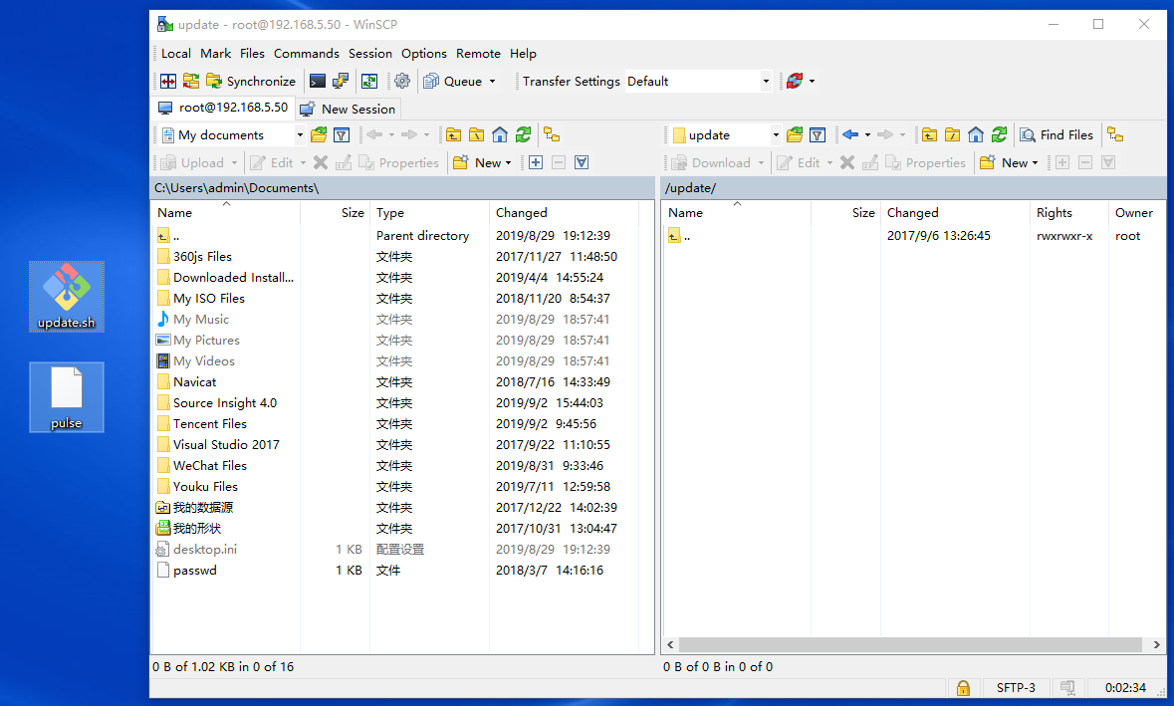

Move the program pulse and update.sh to the directory /update/, then you can see the new pulse and update.sh.

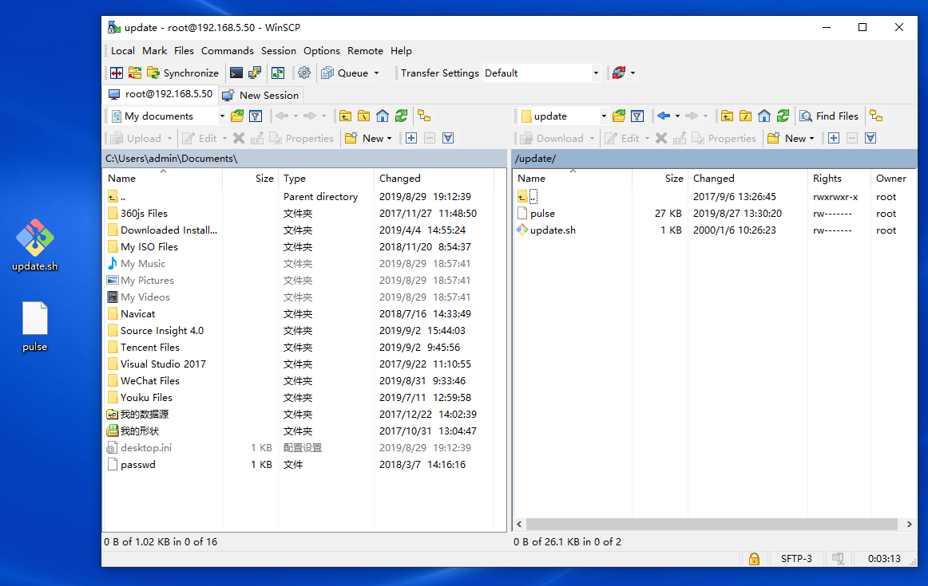

1. Update pulse program

Use console port or ssh to login the setver GTT200, the user name is root, the password is globaltime.

cd/ update command switched to /update directory.

ls command to check the file list, to confirm pulse and update.sh has been copied to /update directory.

operate /bin/sh /update/update.sh

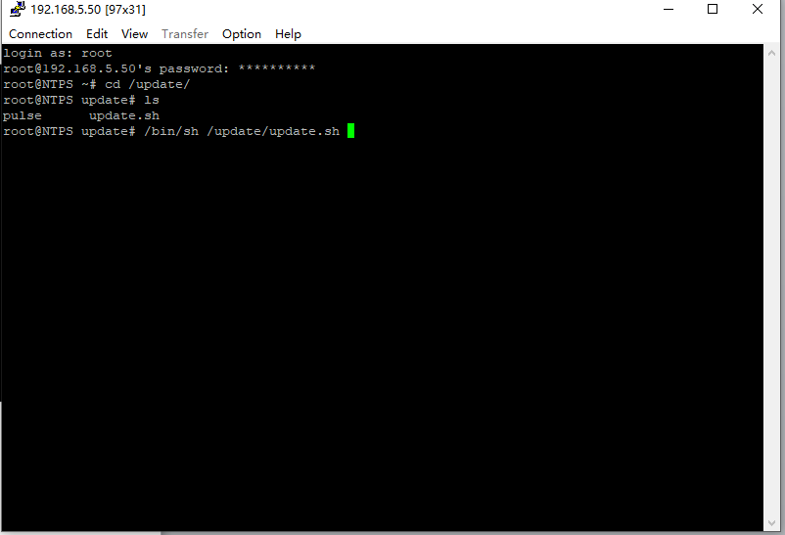

Please update the two pcs of NTP server using the same method.

1. Change the configuration info of pulse, please refer to the file Topology for redundancy 2019.7.25.ppt.